Issue description – Azure web app

Overview: The Azure Web app “cveu-t-mcc-handover-001” experiences intermittent outbound network connectivity issues after slot swaps. Symptoms of this error are:

* HTTP 500 errors when trying to navigate to the web app in a browser
* The app uses Hangfire to run scheduled jobs and these are all failing with TCP errors.
* Simply restarting the app from the Azure portal resolves the issue

# Application logs:

Analyzing the application logs suggests that the issue is directly related to the slot swap operation.

The application is deployed via an Azure Devops pipeline that performs the following operations:

1. Deploy an ARM template that deploy the application and a staging slot.
2. Deploy the latest build artifact to the staging slot.
3. Apply web app configuration to the staging slot (the settings are not sticky).
4. Swap staging slot with production.

The following picture shows the application starting up and functioning properly during the slot swap:

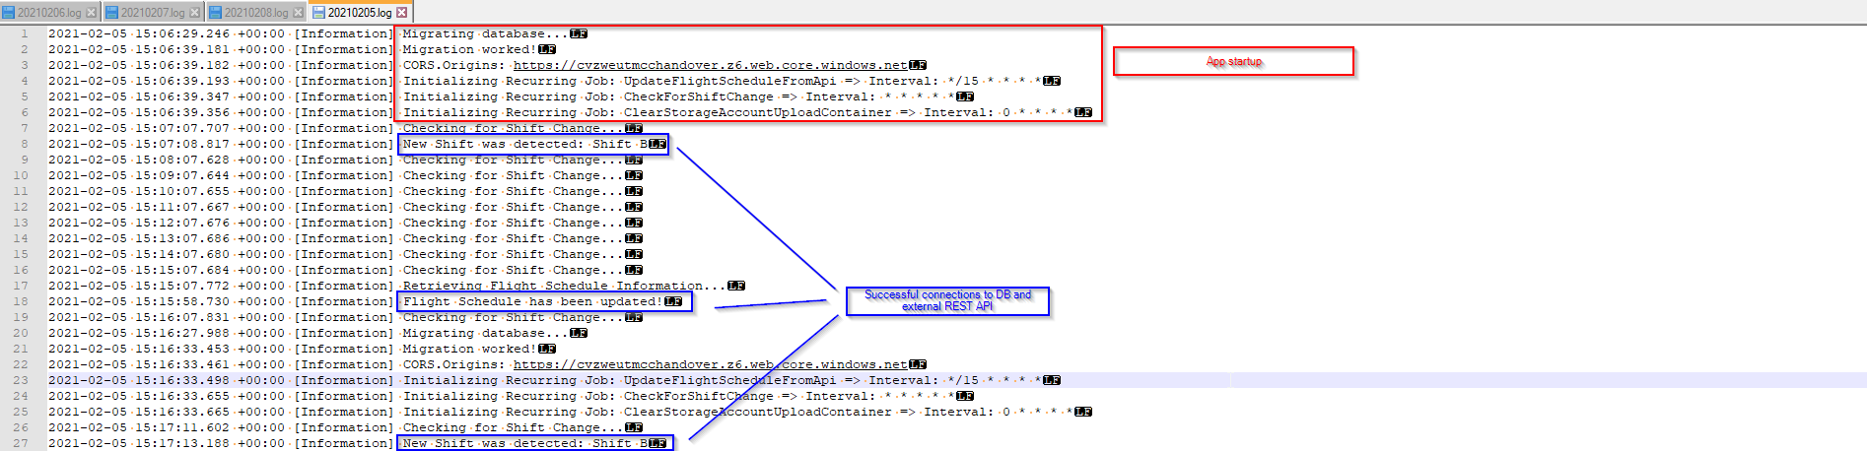

The slot swap started at 2021-02-05T15:04:49 and completed at 2021-02-05T15:17:32:

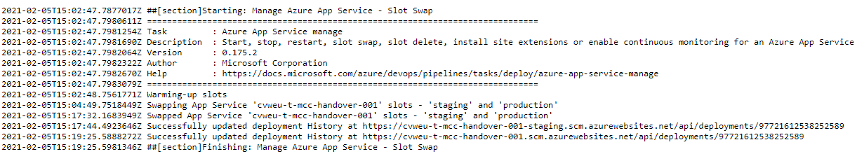

Immediately after the slot swap, the scheduled jobs are failing with network errors:

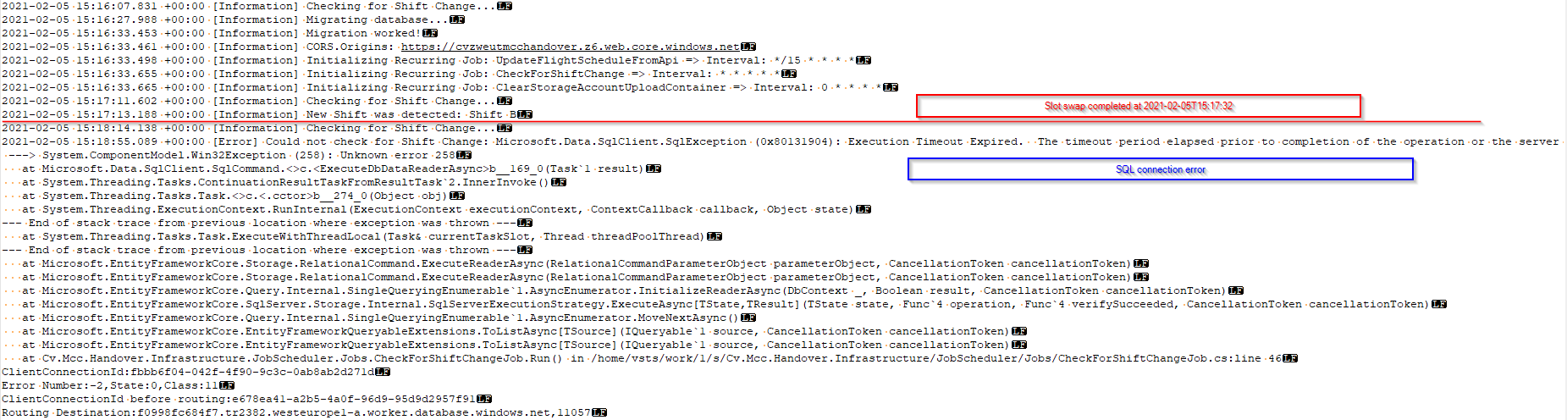

The errors are not only generated on by the SQL client. Here are a few samples:

2021-02-05 15:18:55.089 +00:00 [Error] Could not check for Shift Change: Microsoft.Data.SqlClient.SqlException (0x80131904): Execution Timeout Expired. The timeout period elapsed prior to completion of the operation or the server is not responding.

---> System.ComponentModel.Win32Exception (258): Unknown error 258

at Microsoft.Data.SqlClient.SqlCommand.<>c.<ExecuteDbDataReaderAsync>b__169_0(Task`1 result)

at System.Threading.Tasks.ContinuationResultTaskFromResultTask`2.InnerInvoke()

at System.Threading.Tasks.Task.<>c.<.cctor>b__274_0(Object obj)

at System.Threading.ExecutionContext.RunInternal(ExecutionContext executionContext, ContextCallback callback, Object state)

--- End of stack trace from previous location where exception was thrown ---

at System.Threading.Tasks.Task.ExecuteWithThreadLocal(Task& currentTaskSlot, Thread threadPoolThread)

--- End of stack trace from previous location where exception was thrown ---

at Microsoft.EntityFrameworkCore.Storage.RelationalCommand.ExecuteReaderAsync(RelationalCommandParameterObject parameterObject, CancellationToken cancellationToken)

at Microsoft.EntityFrameworkCore.Storage.RelationalCommand.ExecuteReaderAsync(RelationalCommandParameterObject parameterObject, CancellationToken cancellationToken)

at Microsoft.EntityFrameworkCore.Query.Internal.SingleQueryingEnumerable`1.AsyncEnumerator.InitializeReaderAsync(DbContext _, Boolean result, CancellationToken cancellationToken)

at Microsoft.EntityFrameworkCore.SqlServer.Storage.Internal.SqlServerExecutionStrategy.ExecuteAsync[TState,TResult](TState state, Func`4 operation, Func`4 verifySucceeded, CancellationToken cancellationToken)

at Microsoft.EntityFrameworkCore.Query.Internal.SingleQueryingEnumerable`1.AsyncEnumerator.MoveNextAsync()

at Microsoft.EntityFrameworkCore.EntityFrameworkQueryableExtensions.ToListAsync[TSource](IQueryable`1 source, CancellationToken cancellationToken)

at Microsoft.EntityFrameworkCore.EntityFrameworkQueryableExtensions.ToListAsync[TSource](IQueryable`1 source, CancellationToken cancellationToken)

at Cv.Mcc.Handover.Infrastructure.JobScheduler.Jobs.CheckForShiftChangeJob.Run() in /home/vsts/work/1/s/Cv.Mcc.Handover.Infrastructure/JobScheduler/Jobs/CheckForShiftChangeJob.cs:line 46

ClientConnectionId:fbbb6f04-042f-4f90-9c3c-0ab8ab2d271d

Error Number:-2,State:0,Class:11

ClientConnectionId before routing:e678ea41-a2b5-4a0f-96d9-95d9d2957f91

Routing Destination:f0998fc684f7.tr2382.westeurope1-a.worker.database.windows.net,11057

2021-02-05 15:30:13.672 +00:00 [Information] Retrieving Flight Schedule Information...

2021-02-05 15:30:33.849 +00:00 [Error] Something went wrong while requesting new schedule from FS Api: System.Net.Http.HttpRequestException: Resource temporarily unavailable

---> System.Net.Sockets.SocketException (11): Resource temporarily unavailable

at System.Net.Http.ConnectHelper.ConnectAsync(String host, Int32 port, CancellationToken cancellationToken)

--- End of inner exception stack trace ---

at System.Net.Http.ConnectHelper.ConnectAsync(String host, Int32 port, CancellationToken cancellationToken)

at System.Net.Http.HttpConnectionPool.ConnectAsync(HttpRequestMessage request, Boolean allowHttp2, CancellationToken cancellationToken)

at System.Net.Http.HttpConnectionPool.CreateHttp11ConnectionAsync(HttpRequestMessage request, CancellationToken cancellationToken)

at System.Net.Http.HttpConnectionPool.GetHttpConnectionAsync(HttpRequestMessage request, CancellationToken cancellationToken)

at System.Net.Http.HttpConnectionPool.SendWithRetryAsync(HttpRequestMessage request, Boolean doRequestAuth, CancellationToken cancellationToken)

at System.Net.Http.RedirectHandler.SendAsync(HttpRequestMessage request, CancellationToken cancellationToken)

at System.Net.Http.HttpClient.FinishSendAsyncBuffered(Task`1 sendTask, HttpRequestMessage request, CancellationTokenSource cts, Boolean disposeCts)

at Cv.Mcc.Handover.Infrastructure.Services.FlightSchedule.FlightScheduleService.GetFlightSchedule(Int32 minusDays, Int32 plusDays) in /home/vsts/work/1/s/Cv.Mcc.Handover.Infrastructure/Services/FlightSchedule/FlightScheduleService.cs:line 59

at Cv.Mcc.Handover.Infrastructure.JobScheduler.Jobs.FlightScheduleApiUpdateJob.Run() in /home/vsts/work/1/s/Cv.Mcc.Handover.Infrastructure/JobScheduler/Jobs/FlightScheduleApiUpdateJob.cs:line 46

The errors keep occurring until the application is restarted from the Azure portal:

